 | School of Mathematics  and Physics  Queen’s University Belfast  Belfast  BT7 1NN  Northern Ireland  mpts@qub.ac.uk  www.qub.ac.uk/mp  1 December 2020

Mr Ryan Cullen
23 Sharman Park
BELFAST
BT9 5HJ

Dear Ryan

The School Distinction Award

I am very pleased to inform you that you have been awarded The School Distinction Award for the best overall BSc Performance in Mathematics for the 2019-20 academic year.

Many congratulations on this well-deserved award.

Yours sincerely

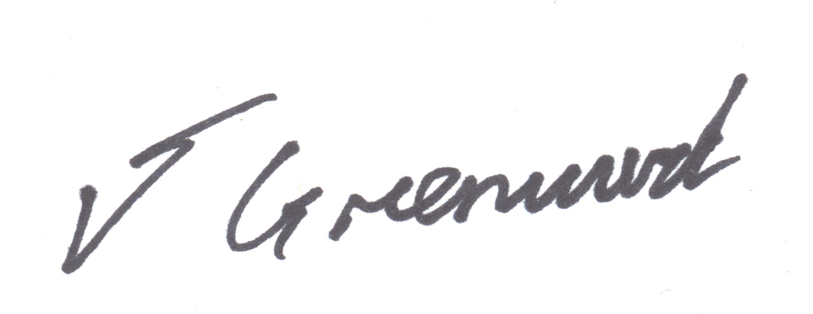

Dr Jason Greenwood
Director of Education

